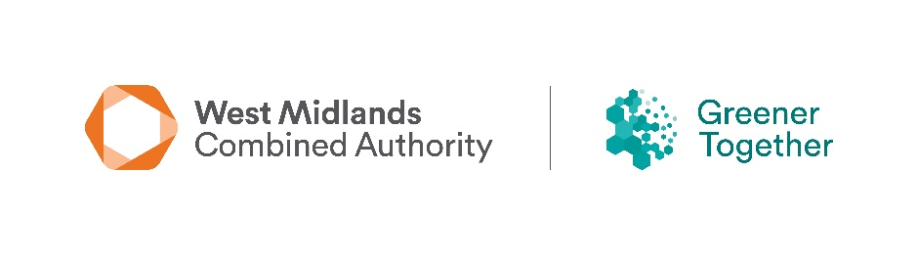

West Midlands Combined Authority
future community-led environment projects
Survey Form

The WMCA are looking to better understand the types of projects that may be seeking grant support in the future; like those from the Community Green Grants and Community Environment Fund programmes. To help us, we would like to collect project ideas, and to see what type of grant help you may need to deliver your future project.

Please note that all awards for the WMCA Community Environment Fund and Community Green Grants have been made now, and completion of this form does not act as part of an application for grant funding or guarantee that you will receive funding from WMCA in the future.

Which of the following themes would your project relate to.
Natural environment ☐
Access to green/blue space ☐
Climate adaptation ☐
Circular economy ☐
Environment awareness ☐
Air Quality ☐
Other (please state) ☐

Briefly describe the overall aim and objectives of your project including how the environment and community would benefit.

continued
If you think that you would need a grant to help you deliver your project, please provide the following information:
Organisation Name
Organisation Type

Project Name
Estimate amount (£’s) required
Project location (include a post code)

Contact Name:
Contact Email:
Contact Tel:

Once complete, please email to environment@wmca.org.uk

